2/22/2023

COAL LAB 5

20k1898

Q1:

INCLUDE Irvine32.inc

.data

arrayB BYTE 60, 70, 80

arrayW WORD 150, 250, 350

arrayD DWORD 600, 1200, 1800

sumB BYTE ?

sumW WORD ?

.code

main PROC

mov eax,0

mov esi,0

mov al,arrayB[esi\*TYPE arrayB]

add esi,2

add al,arrayB[esi\*TYPE arrayB]

call DumpRegs

mov esi,0

mov ax,arrayW[esi\*TYPE arrayW]

add esi,2

add ax,arrayW[esi\*TYPE arrayW]

call DumpRegs

mov esi,0

mov eax,arrayD[esi\*TYPE arrayD]

add esi,2

add eax,arrayD[esi\*TYPE arrayD]

call DumpRegs

exit

main ENDP

END main

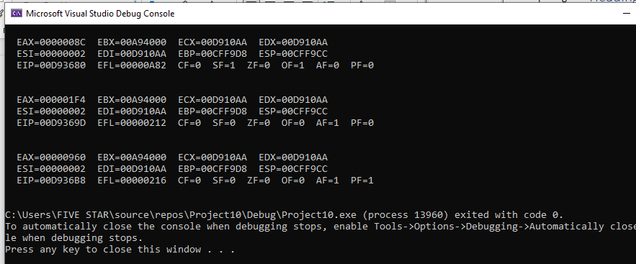

Q2:

INCLUDE Irvine32.inc

.data

arr DWORD 1000, 2000, 4000, 6000

ptrD dword OFFSET arr

ptrD1 dword OFFSET [arr+1]

ptrD2 dword OFFSET [arr+2]

ptrD3 dword OFFSET [arr+3]

.code

main PROC

mov eax,0

mov eax,[ptrD]

mov ebx,0

mov ebx,[ptrD1]

call DumpRegs

mov eax,0

mov eax,[ptrD2]

mov ebx,0

mov ebx,[ptrD3]

call DumpRegs

exit

main ENDP

END main

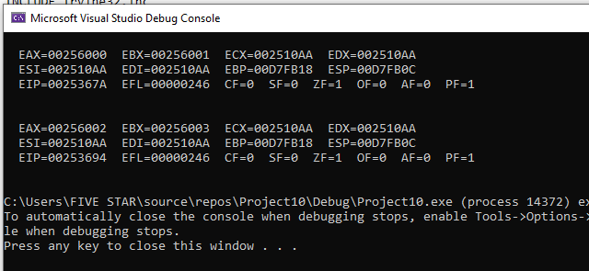

Q3:

INCLUDE Irvine32.inc

.data

arr BYTE 1,2,3,4,5,6

s BYTE 6

.code

main PROC

mov eax,0

movzx ecx,s

mov esi,OFFSET arr

L1:

mov al,[esi+ecx-1]

call WriteDec

call crlf

Loop L1

exit

main ENDP

END main

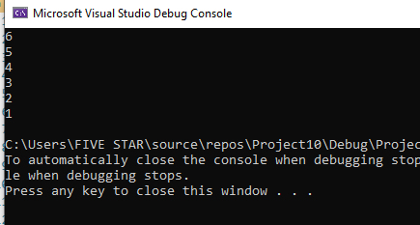

Q4:

INCLUDE Irvine32.inc

.data

b BYTE 1

a BYTE 1

s BYTE ?

.code

main PROC

mov eax,0

mov al,a

Call WriteDec

Call crlf

mov bl,b

Call WriteDec

call crlf

mov ecx,8

L1:

add al,bl

Call WriteDec

call crlf

mov dl,al

mov s,dl

mov a,bl

mov al,a

mov b,dl

mov bl,b

loop L1

exit

main ENDP

END main

Q5:

INCLUDE Irvine32.inc

.data

arr dword 15,10,25,20,30

i dword 0

j dword 0

count Dword ?

x dword 4

temp dword ?

.code

main PROC

mov eax,0

mov ecx,5

L1:

mov count,ecx

mov eax,count

sub eax,1

sub eax,i

mov ecx,eax

mov si,0

mov eax,0

mov ebx,0

L2:

mov ebx,arr[si]

mov eax,arr[si+1]

cmp ebx,eax

ja L3

jmp L4

L3:

mov temp,ebx

mov arr[si],eax

mov arr[si+1],ebx

jmp L4

L4: add si,1

loop L2

mov ecx,count

loop L1

exit

main ENDP

END main